Assignment 9.2
Stone Nettles
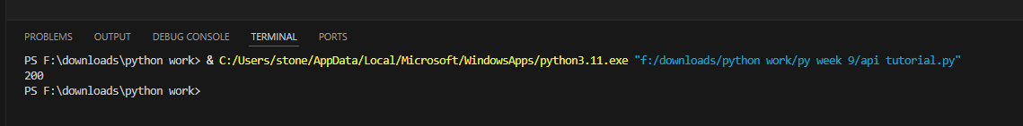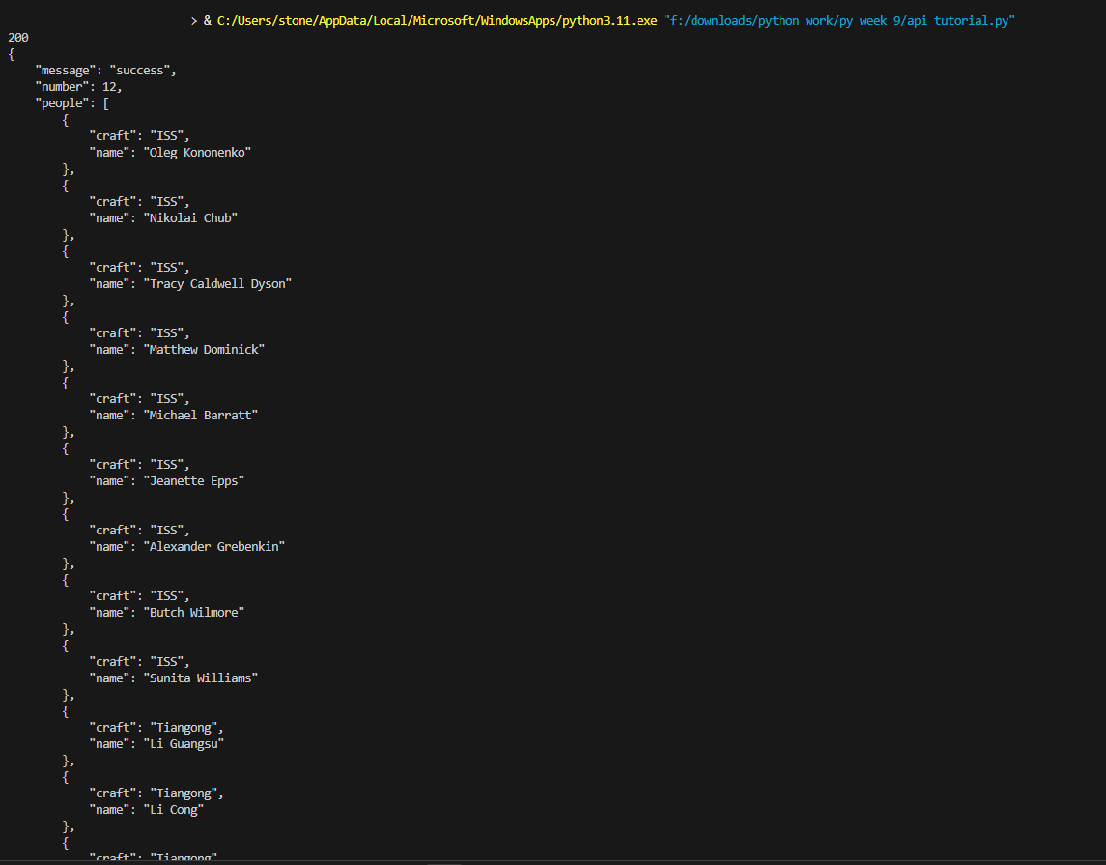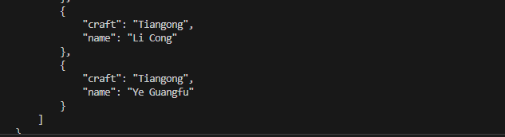
(the end of the output that didn’t fit in one screenshot)
